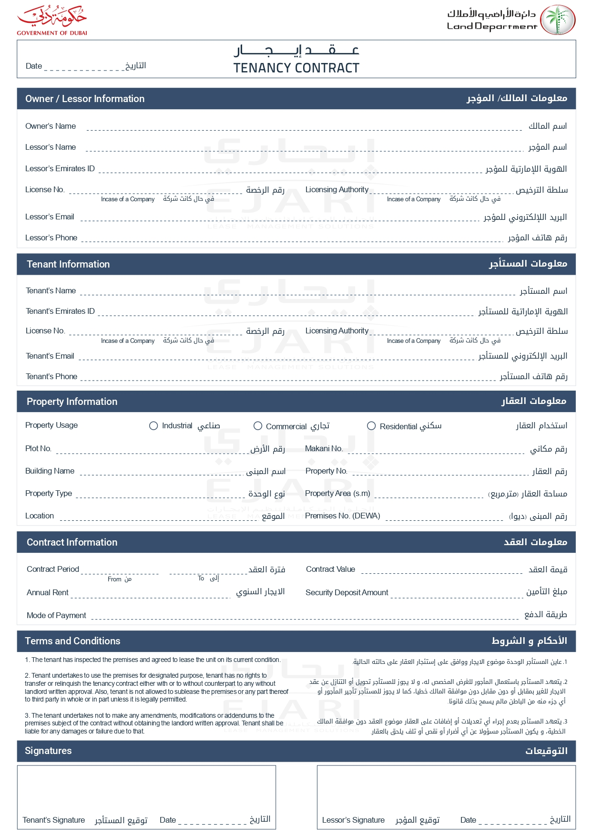

2025-04-15

John Smith

John Smith

john.smith@example.com

+971501234567

David Wilson

david.w@example.com

+971504567890

✓

G-101

Green Villa

1,400.00

GV001

1,050.00 USD

2025-07-15

2025-04-15

0.00 USD

1,050.00 USD

Weekly

